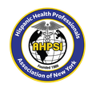 | Hispanic Health Professionals Association, Inc. New York (AHPSI)  Dominican Parade and Festival of Union County, Inc.  “Health, culture, and community for our families”  Mailing Address: 61 Brighton Ave, Perth Amboy, New Jersey 08861 | 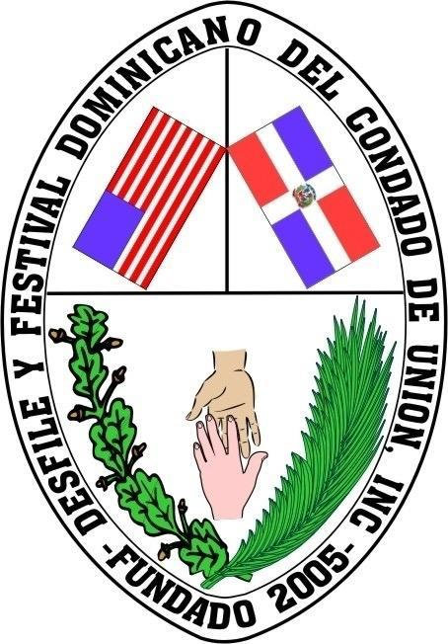

Date: May 29, 2026
Invitation to Sponsor
XIII Annual Community Health Fair
Event Date | Sunday, July 26, 2026
Time | 9:00 AM – 3:00 PM
Location | José Martí & Juan Pablo Duarte School, 25 First Street, Elizabeth, NJ 07206
Expected Attendance | 1,000+ community members
Participating Organizations | 50+ institutions and agencies

Dear Valued Businesses and Community Partners:
The Hispanic Health Professionals Association, Inc. New York (AHPSI) and the Dominican Parade and Festival of Union County, Inc. cordially invite you to become a sponsor of our XIII Annual Community Health Fair, a premier event dedicated to the health and well-being of Hispanic and Dominican families in New Jersey. Your sponsorship will make a direct impact on prevention, education, and access to health services while positioning your business or institution as a leader in community health and equity.
Sponsorship Categories & Benefits
PLATINUM – $2,000 Suggested Donation
- Prominent logo display on event banners and main screen
- Special on-stage recognition
- Brief company presentation (3–5 minutes) during the main program
- Premium booth / display location
- Logo on all communications (website, flyers, social media)
- Certificate of recognition

GOLD – $1,000 Suggested Donation
- Display in a high-traffic area
- On-stage mention
- Logo on printed and digital materials
- Space for brochures or giveaways
- Certificate of appreciation

SILVER – $500 Suggested Donation
- Standard display space
- Thank-you mention from the stage
- Name listed on sponsor board / screen
- Participation certificate

BRONZE – $250 Suggested Donation
- Recognition on general sponsor board
- Public acknowledgment during the event
- Certificate of community support

Friend of the Community – Any Amount You Wish to Give
- Your name or business recognized on our social media
- Public thank-you during the event
- A heartfelt certificate of appreciation

How to Make Your Donation
By Check
Make payable to: Hispanic Health Professionals Association, Inc. New York (AHPSI)
Mail to: 61 Brighton Ave, Perth Amboy, New Jersey 08861
By Zelle
Use phone number: 732-277-9640
(Please include in the memo: “Sponsorship 2026 Health Fair – [Your Company Name]”)
All donations are tax-deductible as allowed by law. An official receipt is available upon request.
Confirmation & Contact
Phone  732-277-9640 | Email  info@ahpsi.org

We deeply appreciate your generosity and trust. With your support, we continue building a healthier, more informed, and united community.

Sincerely,

Dr. Aritmedes Restituyo
General Coordinator
AHPSI & Dominican Parade and Festival of Union County, Inc.

