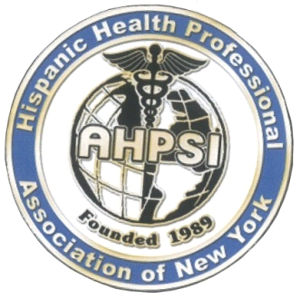  Dr.AritmedesRestituyo.  President  Dr.EliscerGuzman .  President Ad vitam.  Dr.Carlos Williams  Chairman  Dra.TheresaRodriguez.  PastPresident.  Dra.LeonorTavarez.  Secretary  Dr.DiogenesFermin  Executive Director  Dra.Fatima Araujo Japa  Treasurer  Dr. Carlos Mancebo.  Board member  Dra.AngelinaAdames,DDS.  Board Member  Dra.CristyMassielAlcantara  DominicanRepublic,  Representative.  Dr.EdisonAlvarez, Ecuador.  Dra. Carmen Lazala MD  BoardMember  Dra.Nicole de Leon  USMLE, Academy Director  Dra.Ingrid Franco.  BoardMember  Dr.OvelioLopez  BoardMember | Asociacion Hispana de Profesionales de la Salud,Inc NY [ AHPSI]  September, 2018  Dear Doctor,  On this momentous occasion, we wish to invite you to join our upcoming medical missions to Dominican Republic:  October 21-22, 2018  Mission Medical - Sabana Grande de Boya  October 24-28, 2018  Expo National Health Fair - Santiago  Our organization is the Hispanic Association of Health Professionals Inc., NY, founded in 1989, in the City of New York, bringing together all health professionals in the state.  Through 29 years of service, our association has received more than 3,000 professionals benefiting from our orientation, for a better integration into the US Health System. Parallel to all this great work our professionals have served as volunteers in our annual community health fair, with motto: "Decide to be Healthy" in New York, New Jersey, Philadelphia, in Juma-Bonao, DR and Dajabon, DR.  During this event our association will be offering the following services:  Free medical exams,General and Specialized Medical Consultations,Medical Conferences,diverse workshops, prevention demonstrations in health education,Disposable medical material donations, donations of miscellaneous school supplies,Cultural, Artistic presentations, and entertainment for the whole family.  We have a mutual collaboration agreement with the Municipal Hospital Dr. Pedro Heredia Rojas, of Sabana Grande de Boyá Dominican Republic, & Jose Maria Cabral y Baez University Hospital, Santiago, and Nuestra Senora de Regla del Hospital, Bani, Dominican Republic, to inaugurate a national prevention plan, of the Stroke, destined to cover the entire Dominican Republic, Tour through "Los Haitises", National Park, Northeast region of the Dominican Republic.  To carry out these two great missions, we need economic resources, for which, as in previous times, we appealed to you to ask for your support.  With this letter we seek support for the development of these events with your generous financial contribution.Once again, it is our humble appeal to kindly make a generous donation for this missions.  Sincerely,  Dr.AritmedesRestituyo  info@ahpsi.org 732-277-9640

