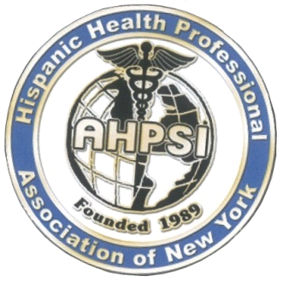  Dr.Aritmedes Restituyo.  President  Dr.EliscerGuzman .  President Ad vitam.  Dr.Carlos Williams  Chairman  Dra.Theresa Rodriguez.  Past President.  Dra.LeonorTavarez.  Secretary.  Dr.DiogenesFermin.  Executive Director.  Dra.Fatima Araujo Japa  Treasurer  Dr. Carlos Mancebo.  Board member  Dra.AngelinaAdames,DDS.  Member  Dra.CristyMassielAlcantara.  Dominican Republic,  Representative.  Dr.Edison Alvarez, Ecuador.  Dra Carmen Lazala MD  Board Member  Dra.Nicole de Leon.  USMLE, Academy Director.  Dra.Ingrid Franco.  Board Member  Dr.Ovelio Lopez.  Board Member. | Hispanic Health Professionals Association of NY,INC, [ AHPSI] over 29 Years of services.  August 2018  To: Doctor!!  Our Association AHPSI, Hispanic Health Professionals, Asssociation Inc. NY, is pleased to invite you to participate in these 2 major events:  Medical Mission Sabana grande de Boya.,Dominican Republic Otubre 20-21, 2018.  Expo National Health Fair, Santiago, Dominican Republic, Octube 24-27,2018  During these events our association together with our distinguished guests, agencies and local medical and cultural institutions, we will be offering the following services:  1.Various medical exams  2.Conferences, in prevention and education of chronic diseases more frequent for the Dominican Republic.  3.Various workshops.  4.Courses of international certification in Cardiopulmonary resuscitation [CPR & Basic Life Support [BLS]  5.We will be inaugurating the first pilot plan for national prevention of stroke in the Dominican Republic.  6.Various Artistic & cultural presentations, related to Dominican cultural identity.  This program has the confirmed support of Dr. Carlos Williams, of Virginia, Dr. Frances Robles, of Florida, Dr. Ivan Subervi of Puerto Rico, Dr. Mario Paulino, Pediatrician, Puerto Rico. Dr. Sergio Martinez, NY, Dr. Diogenes Fermin, NY. Dr. Aritmedes Restituyo, New Jersey.  It is in our interest that you travel with us offering medical services, conferences, donations in medical supply to support this mission, or with your financial donation.  See separately the pre-confirmed General Program, the included travel package and the different levels of sponsorship.  For your convenience our association has reached an agreement with Delta Airlines & Jet Blue, for your air transportation if you need it, the deadline to reserve this way is September 7, 2018.  On behalf of all our organizing committee, I would like to thank you in advance for your support and consideration of these great events in which our association is making a great effort to sustain permanently for the benefit of our patients in the Dominican Republic.  "Helping the one who needs it is not only part of the duty, but also part of the happiness"  Jose Marti  Dr.Aritmedes Restituyo.  info@ahpsi.org  732-277-9640.

